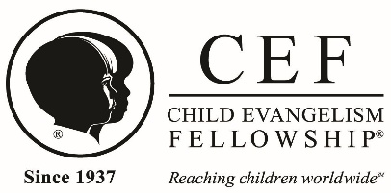

Mandated Reporter Training (Act 31)
After reading the attached Mandated Reporter FAQ document, please answer the following questions, sign and return this form to your local CEF chapter. This must be completed prior to attending or participating in any CEF ministry events where there is direct contact with children.

- What is the purpose of the Pennsylvania Child Protective Services Law (CPSL)?

- What actions or behaviors are considered child abuse under CPSL?

- Who qualifies as a perpetrator of child abuse according to the CPSL?

- Who is considered a mandated reporter, and what are their responsibilities?

- What steps must a mandated reporter take to report suspected child abuse?

- What happens after a report of suspected child abuse is made to ChildLine?

- What is my role as a CEF® volunteer who has direct contact with children?

I understand this document will be on file as part of my required child protection paperwork in my local CEF office.

Signed________________________________________________________Date_________________

